# Team system specification

For our project we have decided to do a website aimed at connecting people who travel around the world. We want them to be connected to keeping each other up to date on their travel trips they are doing personally and being able to share them. We have individual tasks and single tasks with everyone getting a subcomponent to complete. But first we need to talk about our group component below is our group work:

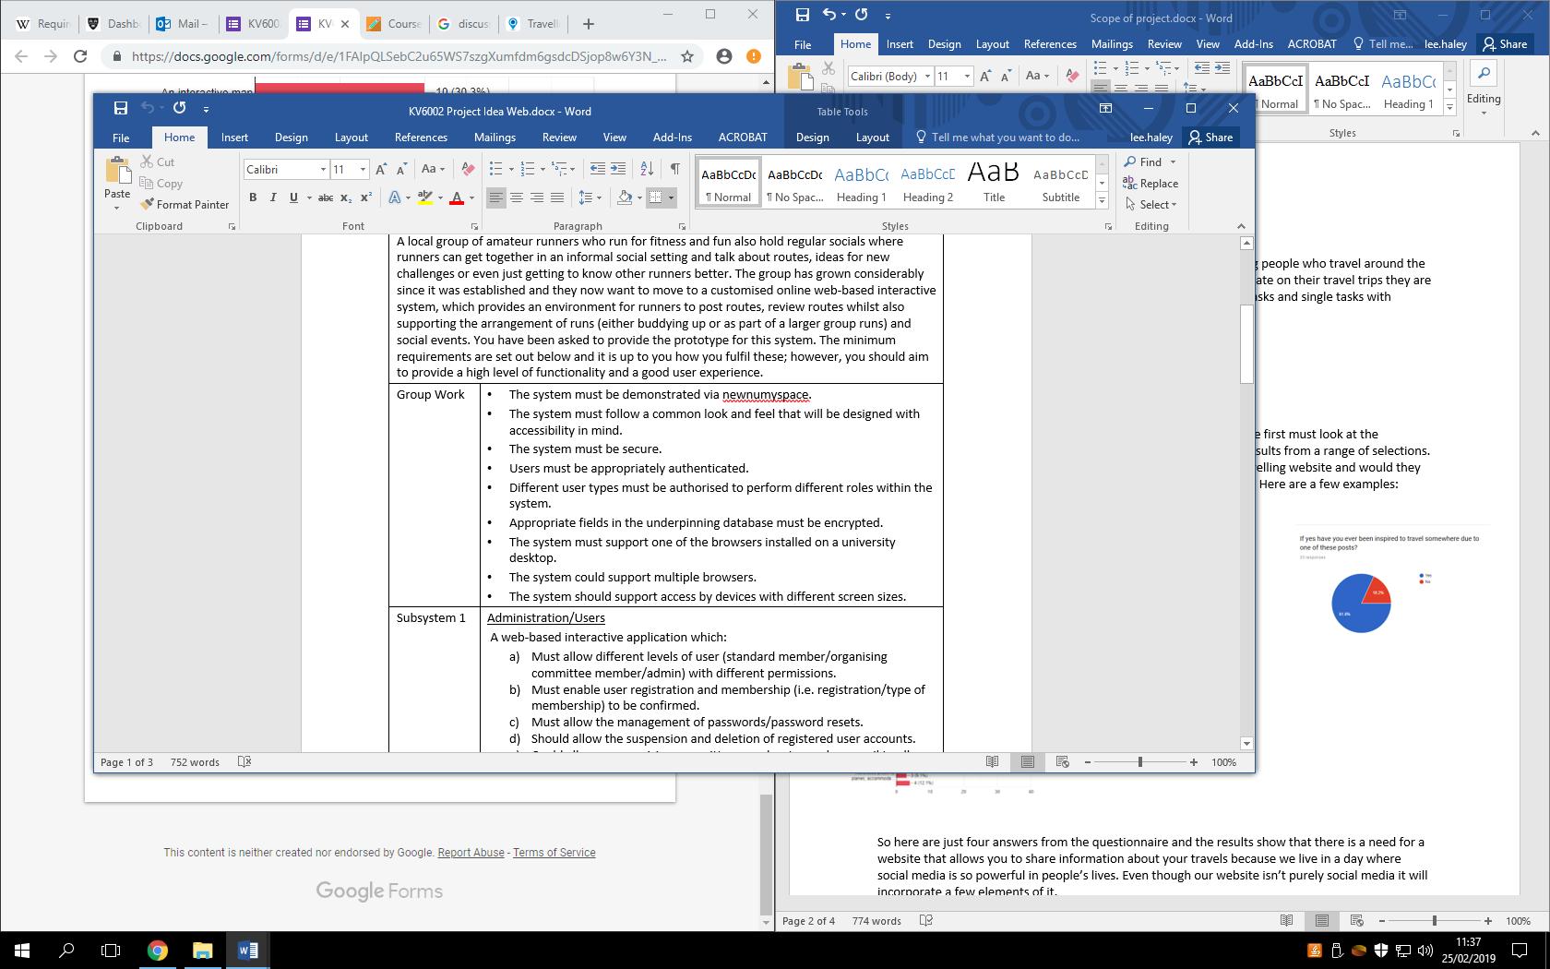

This is our group work that we are going be needing to do for our group project these tasks range from security, where it is hosted, the look and feel of the website and functionality of the website.

## Stakeholder questionnaire

To get the idea of our project and choosing of the subcomponents we first must look at the standards we got advised by the stakeholders these are a range of results from a range of selections. The stakeholders are members of staff, consumers, people who are interested in travelling, project supervisor and group members.

The question’s varied from if they wanted a social media style of travelling website and would they be alright with sharing their information of places they have been to and what features they wanted to see on the website. Here are a few examples:

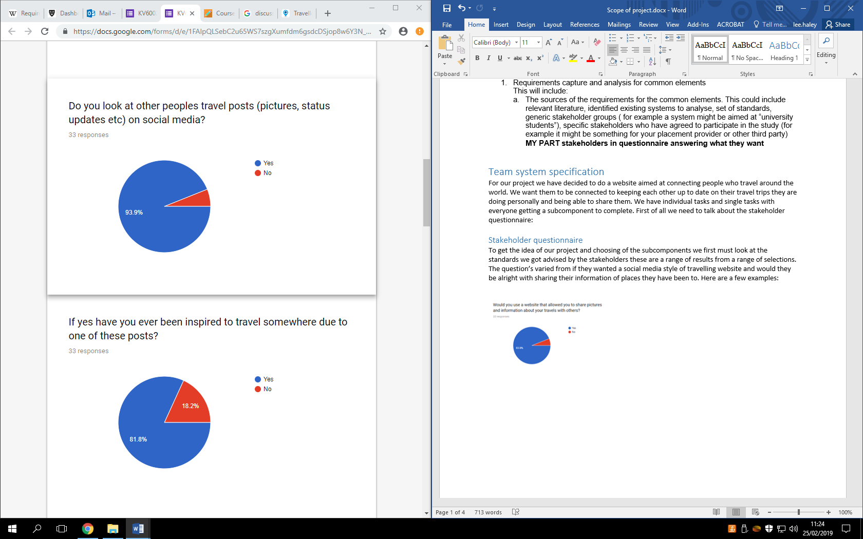

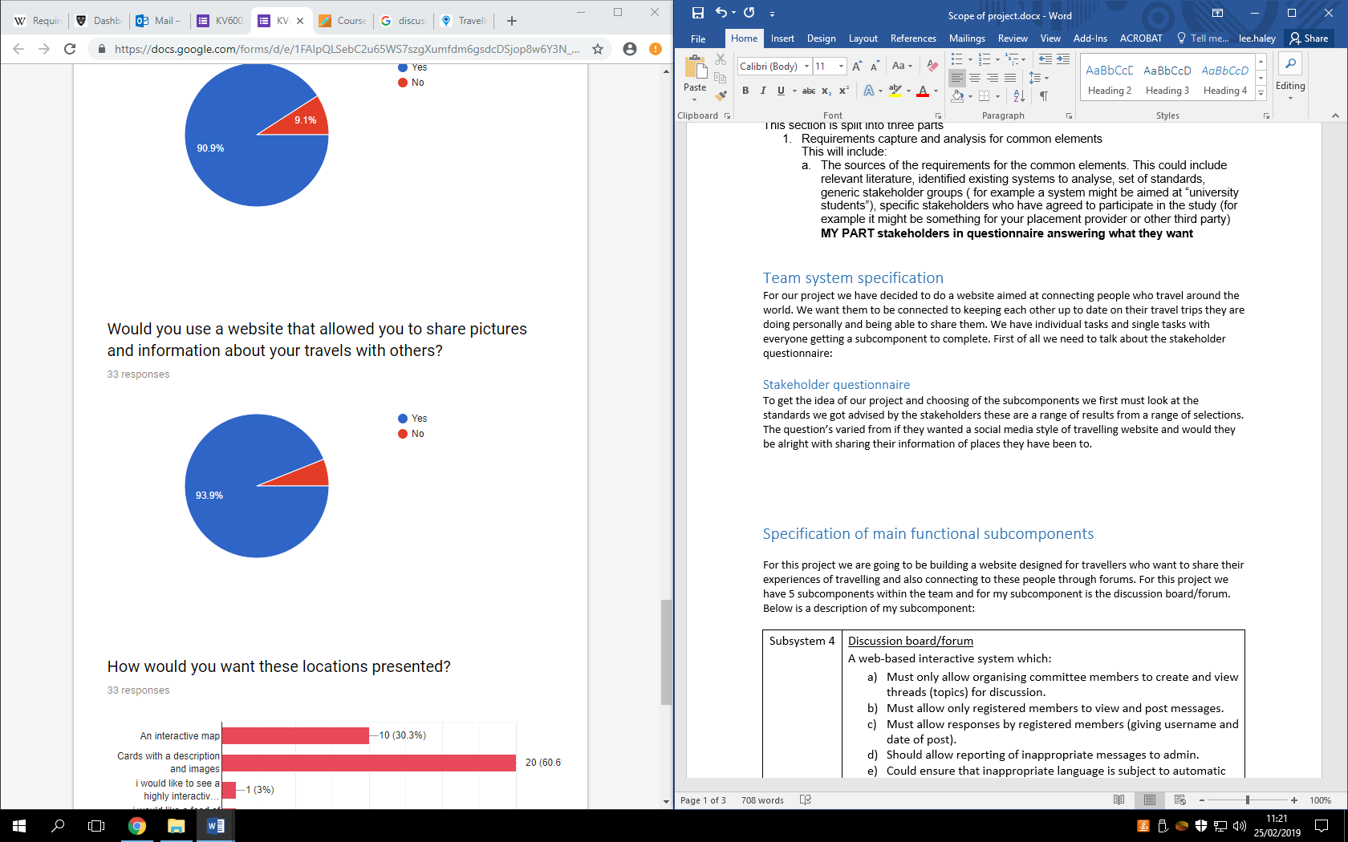

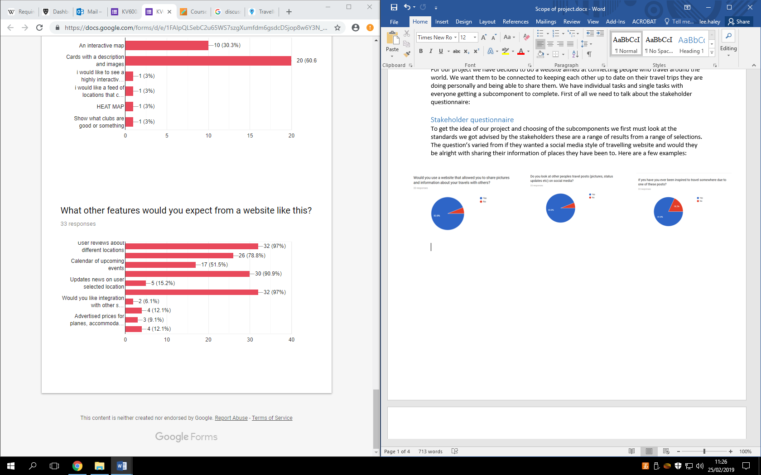

So here are just four answers from the questionnaire and the results show that there is a need for a website that allows you to share information about your travels because we live in a day where social media is so powerful in people’s lives. Even though our website isn’t purely social media it will incorporate a few elements of it. The reason why we have used a stakeholder questionnaire is because they are good way to collect data from a range of people to see what they want and these people who we interview are key to our idea succeeding so there input is vital. Questionnaires can be designed and used to collect vast quantities of data from a variety of respondents. They have a number of benefits over other forms of data collection: they are usually inexpensive to administer; very little training is needed to develop them; and they can be easily and quickly analysed once completed. (Birmingham, P. and Wilkinson, D., 2003)

So with all these results we refer back to our group work which are the objectives that centre on the functionality, look and feel and the security of the website. Given the results we gotten back I think the objectives we have set ourselves will please the demographic we are trying to aim for.

## Relevant systems

### Travello

First of all we have travello which is purely an app which allows travellers to connect with each other. You have to download the app to access the whole system as the website just gives it a description of what it is. A social network for travellers Maybe you’re a backpacker, a solo traveller, a digital nomad or maybe you’re not even travelling right now but would love to meet travellers nearby? It doesn’t matter what type of traveller you are, on Travello you can tailor the app to create the community you want (Travello, 2019). This is what it says on the first page of the website it is promoting that it is a social network for travellers and it is for anyone for any type of need it is heavily promoting that this app is creating an enjoyable travel community. Below is what the app looks like:

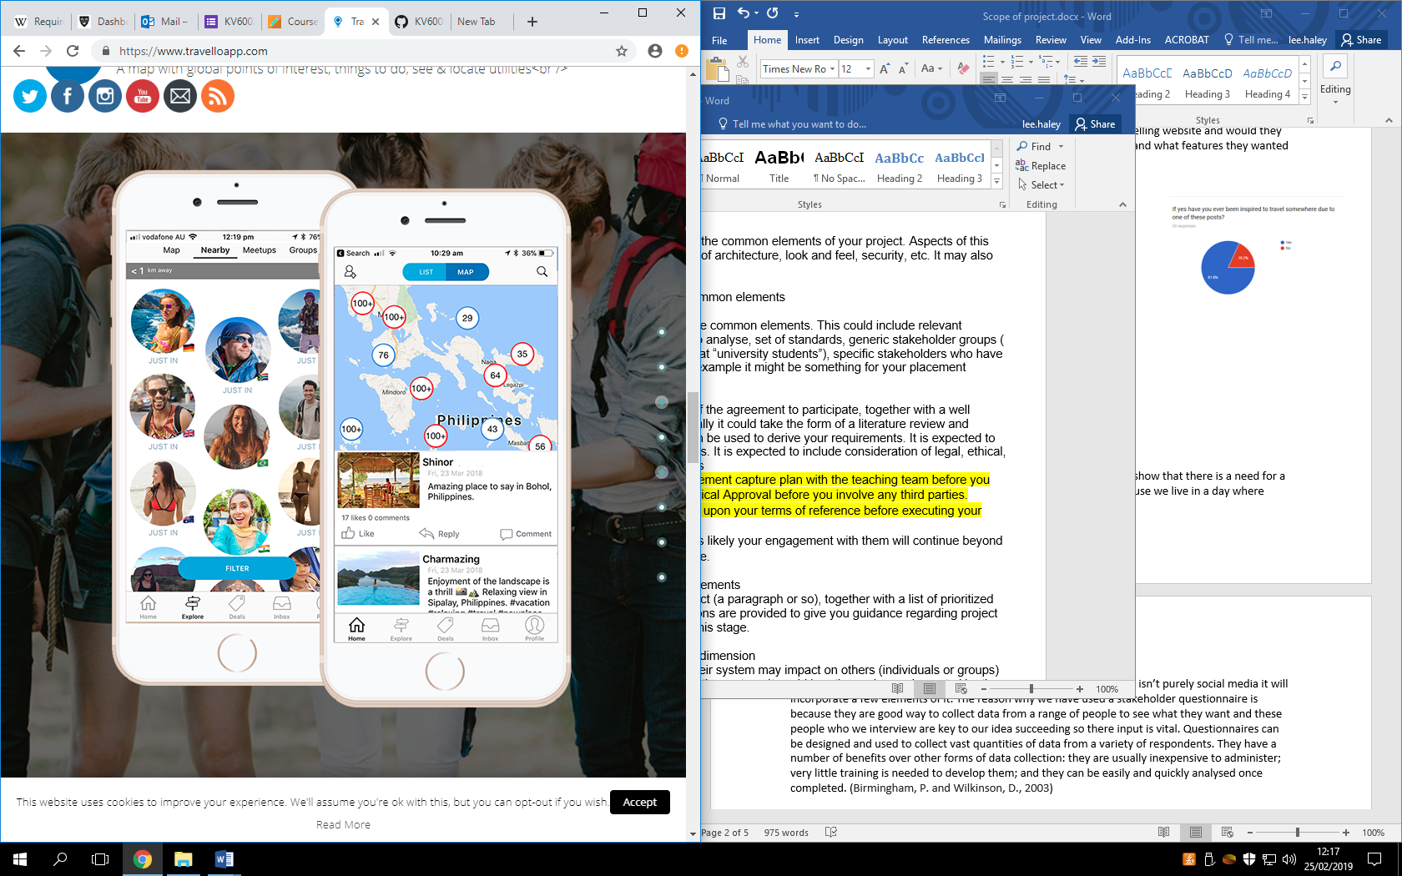 (Travello, 2019)

The app has many features it has map of the world and pretty much every place that is of a travellers interest all has many waypoints of medical centres, ATM’s, points of interests, hotels and social feed which includes interest groups. Travello say this about their map: The ultimate global travel companion map is now on Travello! Locate attractions, hostels, campgrounds, transport, nightlife, restaurants, shopping, fuel stations, things to do, places to see, local businesses and much much more to come! This interactive travel map is your vital trip planning companion feature. Great for backpackers looking for hostels, campervan stops or just an urban tourist looking for things to do in a city.

It has a lot of functionality but the design of the app is a bit too clustered it almost has too much information for the app itself to contain. Nether the less though it has a lot of functionality on it and the functionality it has is perfect example of what we are trying to accomplish but obviously the main difference and why travello has been included in my research is because it is an app, this app is also being targeted for people in the united states of America because when you sign up to the app you need to put in an American phone number so there is a gap in the market for travellers in the UK that need a system like this.

### TripAdvisor

For our next website that we have market researched is TripAdvisor. TripAdvisor is the most successful and well known travel website in the world if you want to know about a hotel or a restaurant in a different country you’re travelling to you are extremely likely to use TripAdvisor. It has many functionalities to it obviously it is best known for leaving reviews but it has many lists of things to do, restaurants, flights, package holidays and the list goes on. Here is a look at the opening navigation bar you’re met with on the home page:

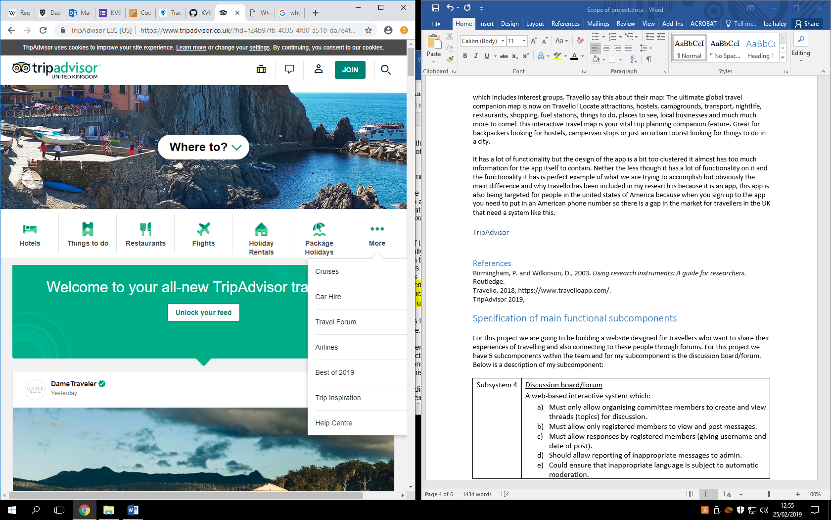(TripAdvisor, 2019)

As you can see here it has many options the ones I listed before and it has travel forums, car hires, best of 2019 etc. just at the bottom of this screenshot you can see the start of the social feed they have within the website which is a feature we want to have. TripAdvisor has a lot of the functionality we are trying to accomplish within our website it has the points of interests, the social feed, discussion forums. It is however a very long website length wise and you can often feel like your scrolling for minutes just to get to the bottom of the site and even though with social media websites you are supposed scrolling for a long amount of time this shouldn’t happen on the home page unless the user knows for certain it is that type of page. Another thing is with TripAdvisor it doesn’t have any maps with points of interests on them you have to search by continent then by country and it is a very long process, this is another point we can take on board.

## Relevant literature

For our project we needed to expand our little knowledge that we already know about the travel sector and whether it will be good for a website with social media components specially for travelling. For this I used: what do we know about social media in tourism? A review (Zeng, B. and Gerritsen, R., 2014). Obviously when we were thinking about this idea we wanted to target a demographic that is very in at the moment and we thought social media and sharing experiences is one of the staples of people’s lives at the moment. Social media is changing the tourism culture. Paris (2011, 2012a, 2012b) has concentrated on backpackers using social media, and even coined a new word “flashpacker” to describe a backpacker who relies heavily upon social media in his/her entire travel process including before, during and after travel (Zeng, B. and Gerritsen, R., 2014). So obviously people use social media heavily when on holiday so why not make a website that has some fundamentals from that and add even more stuff centred around the travel industry.

We also needed to look at the fact we needed to connect our users and why that’s such a vital part of our project. Social media is important for consumers to acquire information but also for generating their own content to communicate with others (Zeng, B. and Gerritsen, R., 2014).

# Specification of main functional subcomponents

For this project we are going to be building a website designed for travellers who want to share their experiences of travelling and also connecting to these people through forums. For this project we have 5 subcomponents within the team and for my subcomponent is the discussion board/forum. Below is a description of my subcomponent:

|  |  |
| --- | --- |
| Subsystem 4 | Discussion board/forum  A web-based interactive system which:   1. Must only allow organising committee members to create and view threads (topics) for discussion. 2. Must allow only registered members to view and post messages. 3. Must allow responses by registered members (giving username and date of post). 4. Should allow reporting of inappropriate messages to admin. 5. Could ensure that inappropriate language is subject to automatic moderation. |

So here we have 3 must subsections, one should and one could. I will obviously be aiming to complete all of them to an exceptional level. These are just guidelines so that the first 3 objectives have to be done and they are a bit difficult but will be done. The second last one will be challenging but it should be included within my subsection. Then the last objective is of great difficulty and if included will create a perfect discussion board for what I am wanting to create. All of these goals even though the latter are difficult they will be included within the discussion board so that we can create a great website. This also helps me have a guideline for prioritising the work that I will need to be doing.

## Stakeholder input

So for our team to produce this idea for our project we needed some input from stakeholders. So to get these results we ran a questionnaire and got some results back to see what areas we could improve on. So for my subsection which is the discussion board we needed to know whether it would be a good idea or not and these were the results we got back:

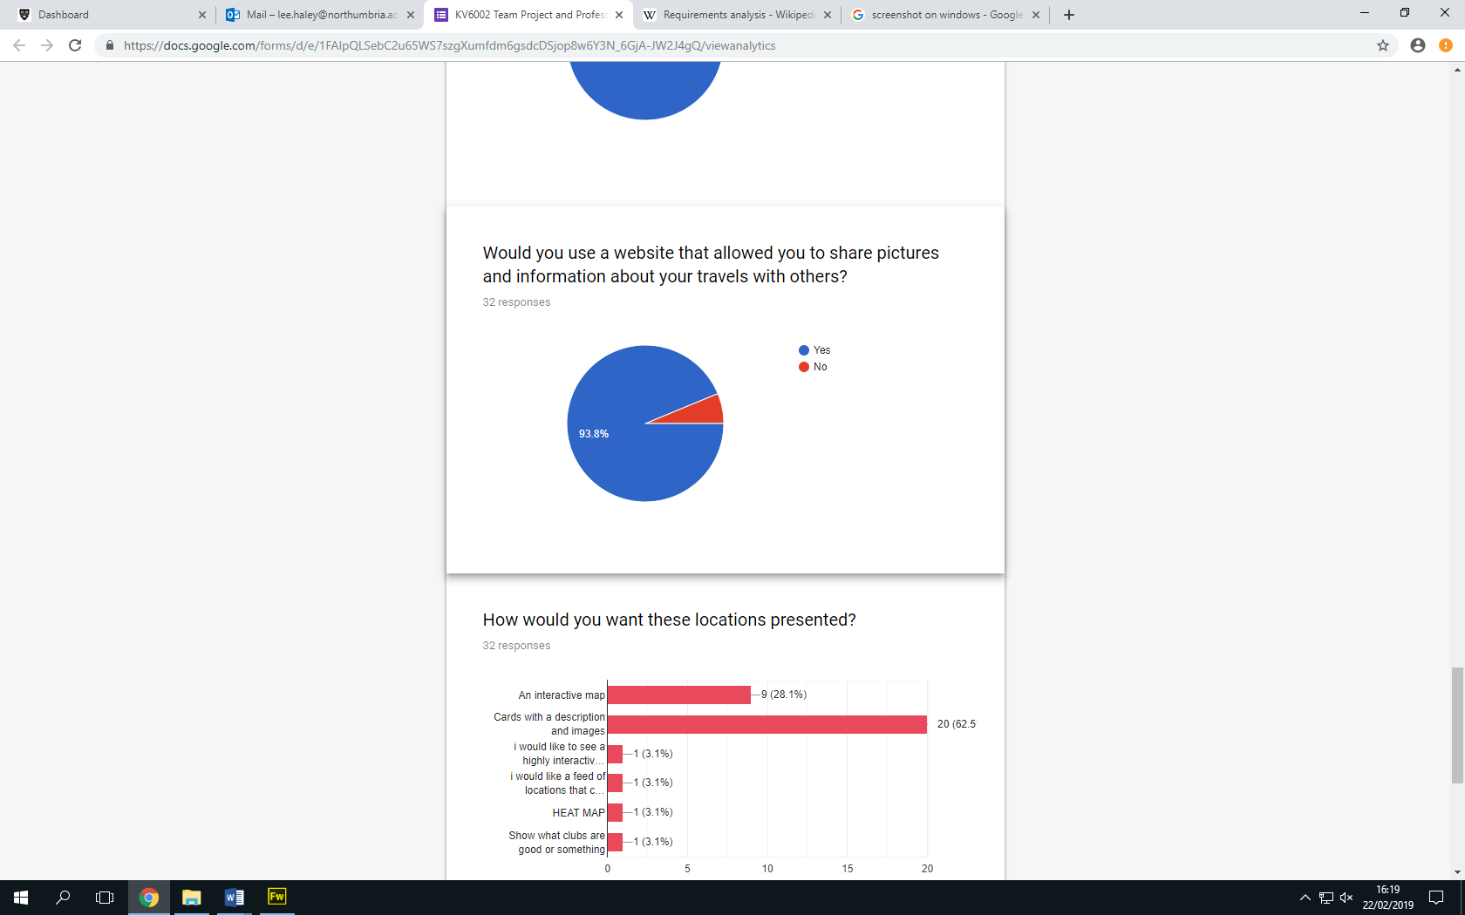

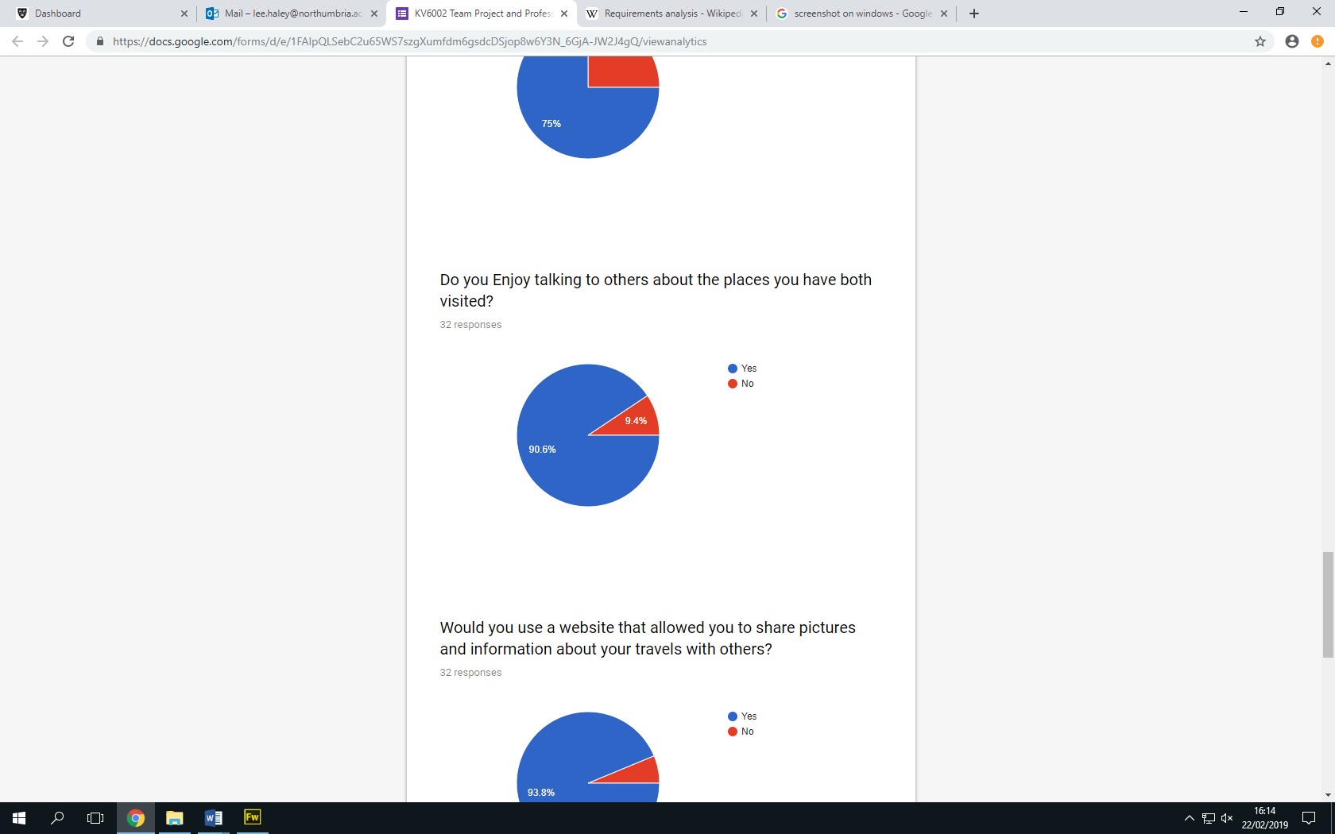

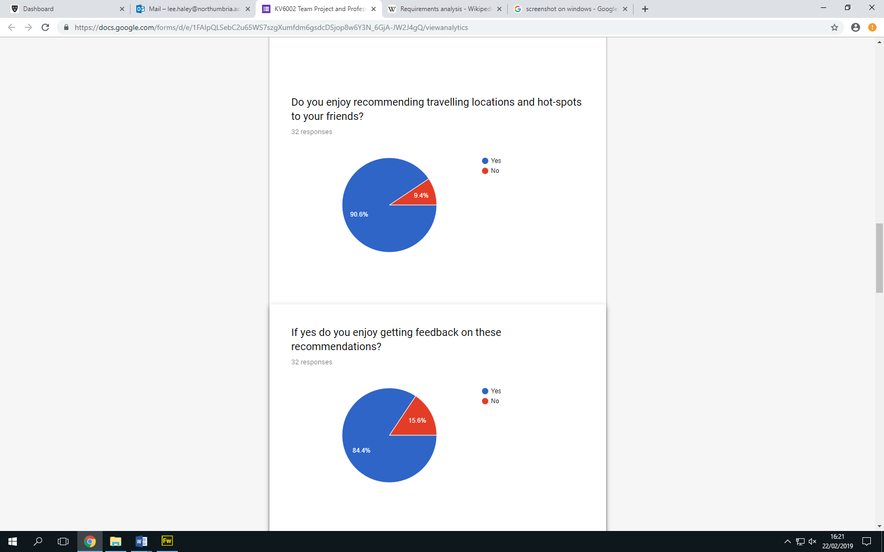

So these are the results we got back from stakeholders regarding my specific subsection. So we can see that they want a website where they can share and talk about their travels, they also like recommending places for travelling. So with these results they show that there is a gap in the market for a website we are trying to create and people want to have a social media specifically for their travelling and they want to share their experiences. So with this we decided to do the website and everyone’s subsection with the results we got regarding my subsection we decided to put in the discussion board as we thought it would be vital for our project.

## Predicted look for system

For my discussion forum I need it to have all of the subcomponents that I mentioned earlier. So with this when I was doing the market research earlier in the task for our group task I researched TripAdvisor and looked at their discussion boards and saw how the look and feel of them were like they divide them up into continents then pick a country and choose a topic that has been created or create a new topic for a specific country. For my discussion board I will have a list of countries then people can see existing forums or create a new but with mine they will have to be logged in a organising member to even create one of these forums and if they are not a member of the site then they will need to be to choose a forum. My forums will also have a zero tolerance on offensive language.

## References

Birmingham, P. and Wilkinson, D., 2003. *Using research instruments: A guide for researchers*. Routledge.

Travello, 2018, https://www.travelloapp.com/.

TripAdvisor 2019, <https://www.tripadvisor.co.uk/?fid=f24b97fb-4035-4f80-a518-da7e4f94a6c0>.

Zeng, B. and Gerritsen, R., 2014. What do we know about social media in tourism? A review. *Tourism management perspectives*, *10*, pp.27-36.